MFCC:
Feature Map of 13 coefficients:
Layer 1:
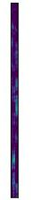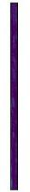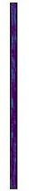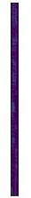
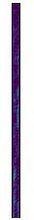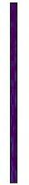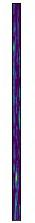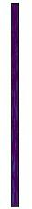

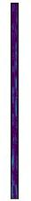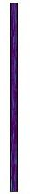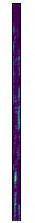
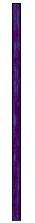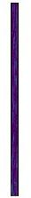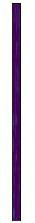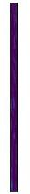

MaxPooling of Layer 1:
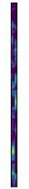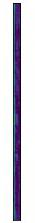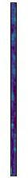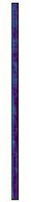
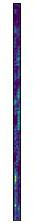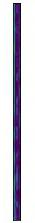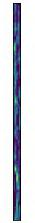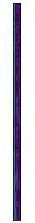

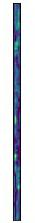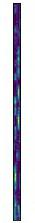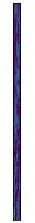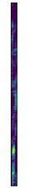

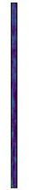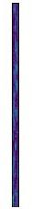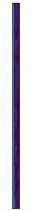

Layer 2:
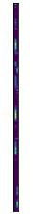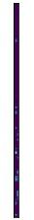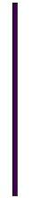
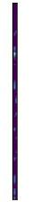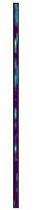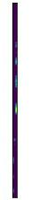
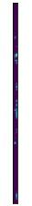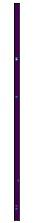
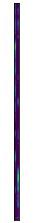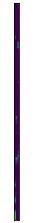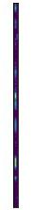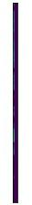
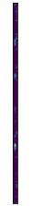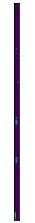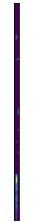
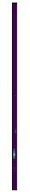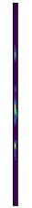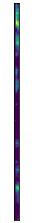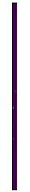
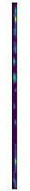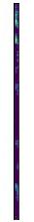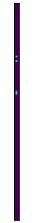
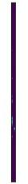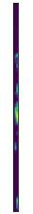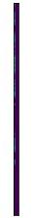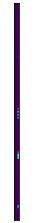

Maxpool of layer 2
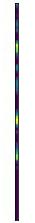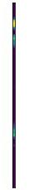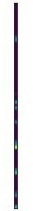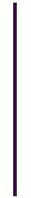
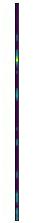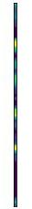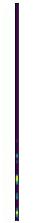
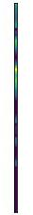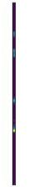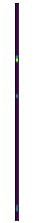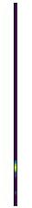
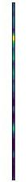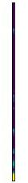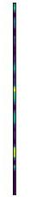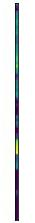
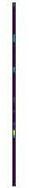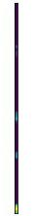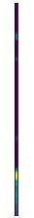
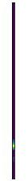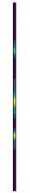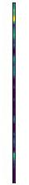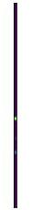
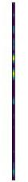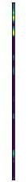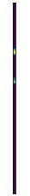
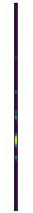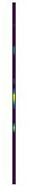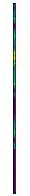
26 coeff:
Layer 1

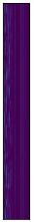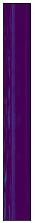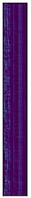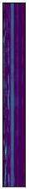
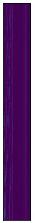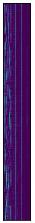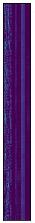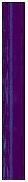

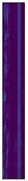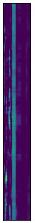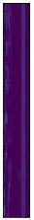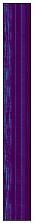
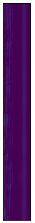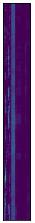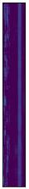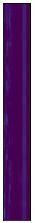
Maxpool of layer 1:
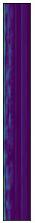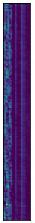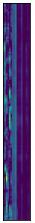
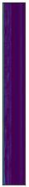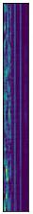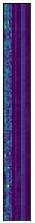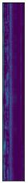
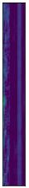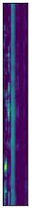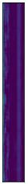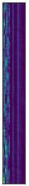
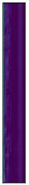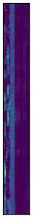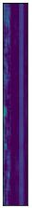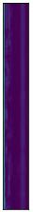
Layer 2:
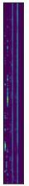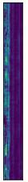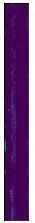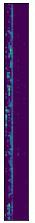
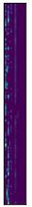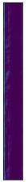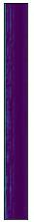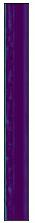

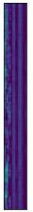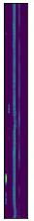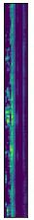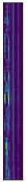
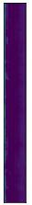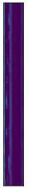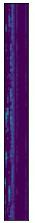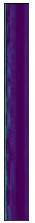
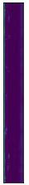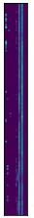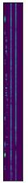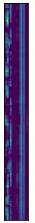
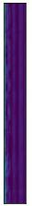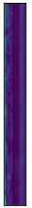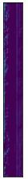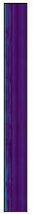
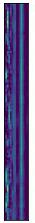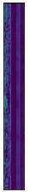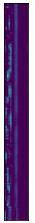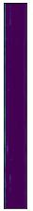
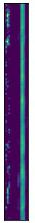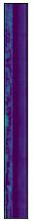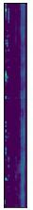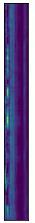

Maxpool of Layer 2:
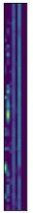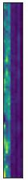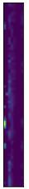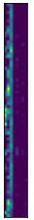
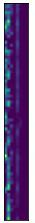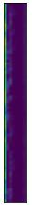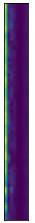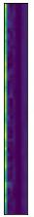
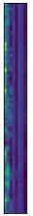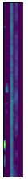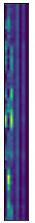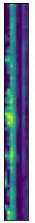
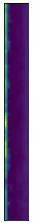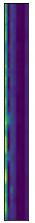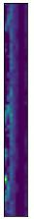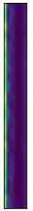

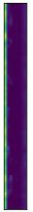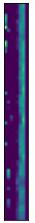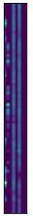
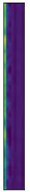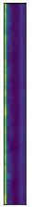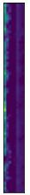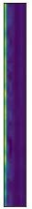

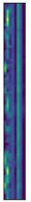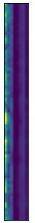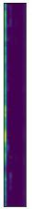
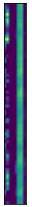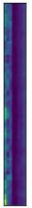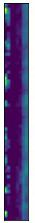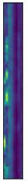

39 coeff:

Maxpool of layer 1::

Layer 2

Maxpool of Layer 2:

27 coeff:
Layer 1:
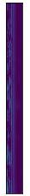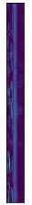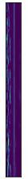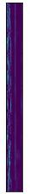
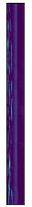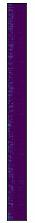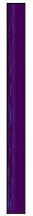
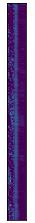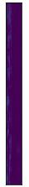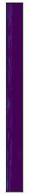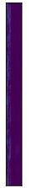
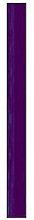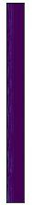

Maxpool of layer 1:
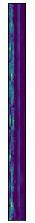
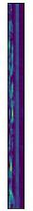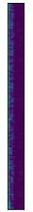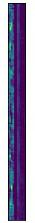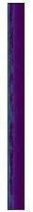
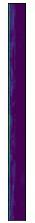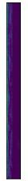
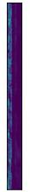

Layer 2:
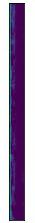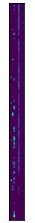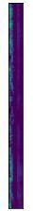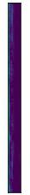
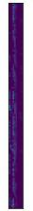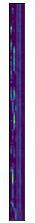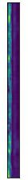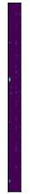
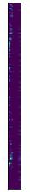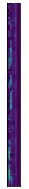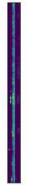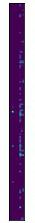
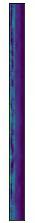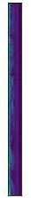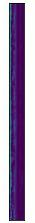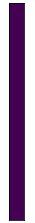
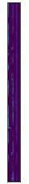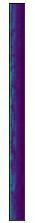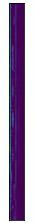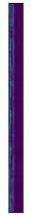
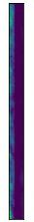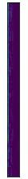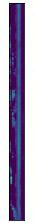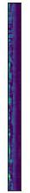
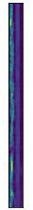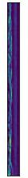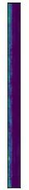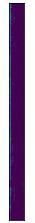
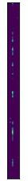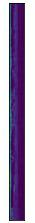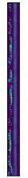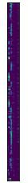

Maxpool of layer 2:
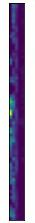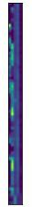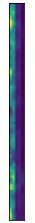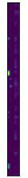
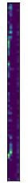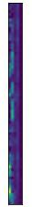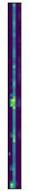
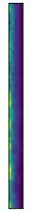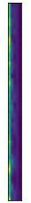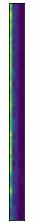
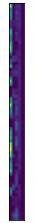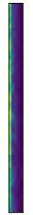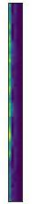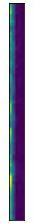
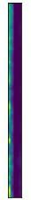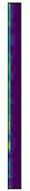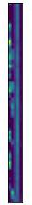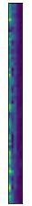
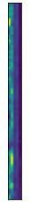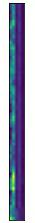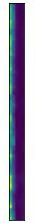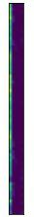
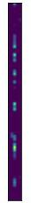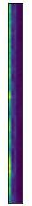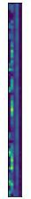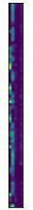
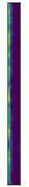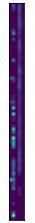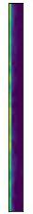

LFCC :
13 coeff:
Layer 1
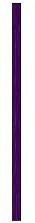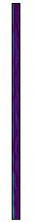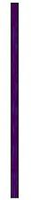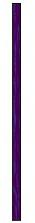
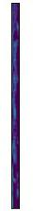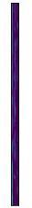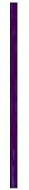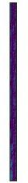
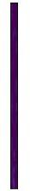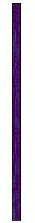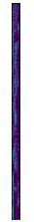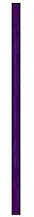
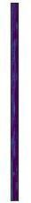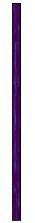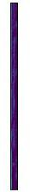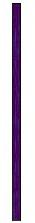

Maxpool of layer 1
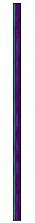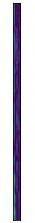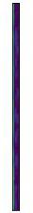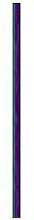
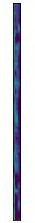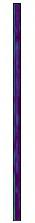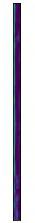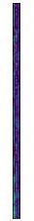
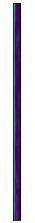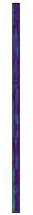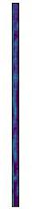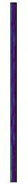
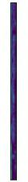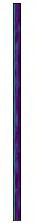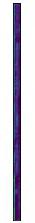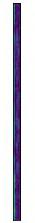

Layer 2
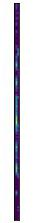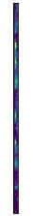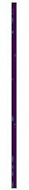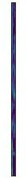
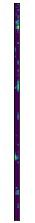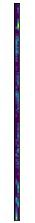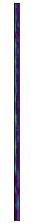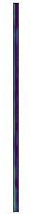
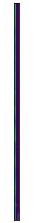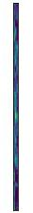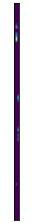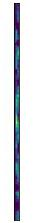
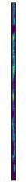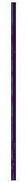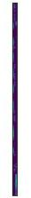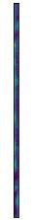
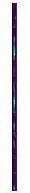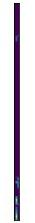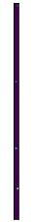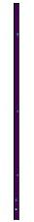
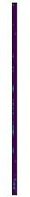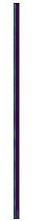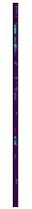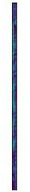
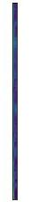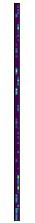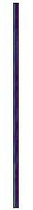
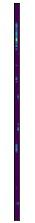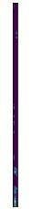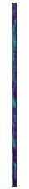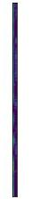

Maxpool of layer 2
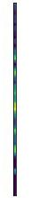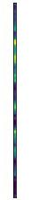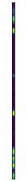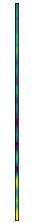
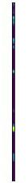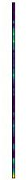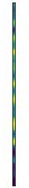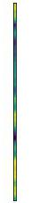
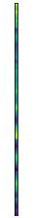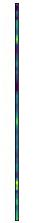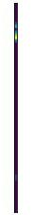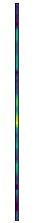
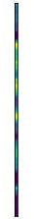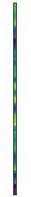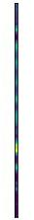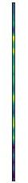
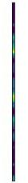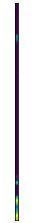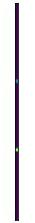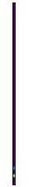
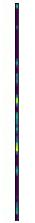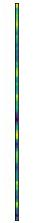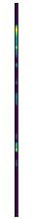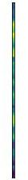
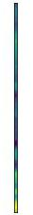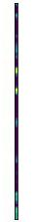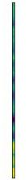
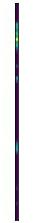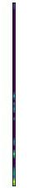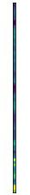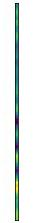

26 coeff:
Layer 1
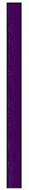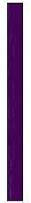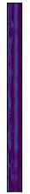
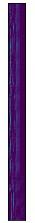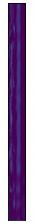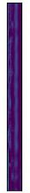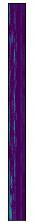
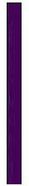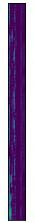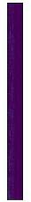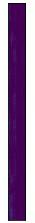
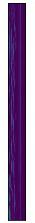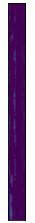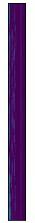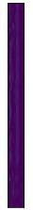

Maxpool of layer 1
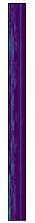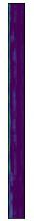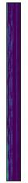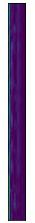
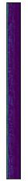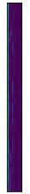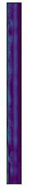
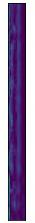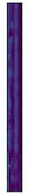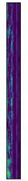
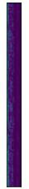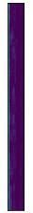

Layer 2
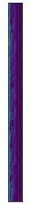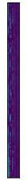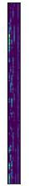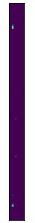
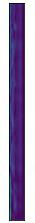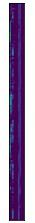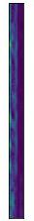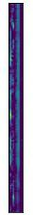
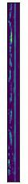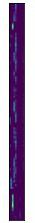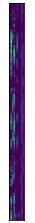
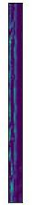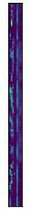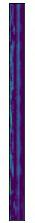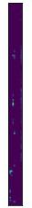
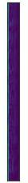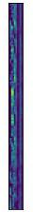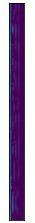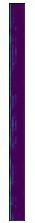
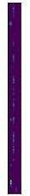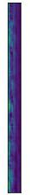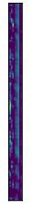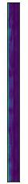
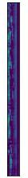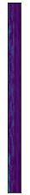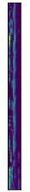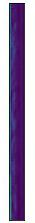
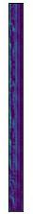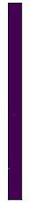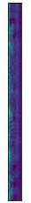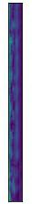

Maxpool of layer 2
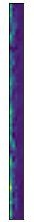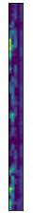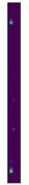
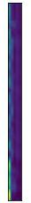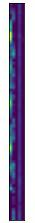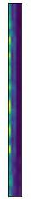
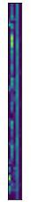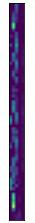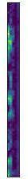
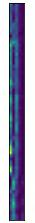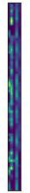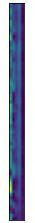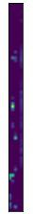
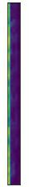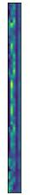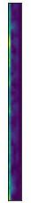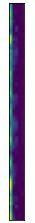
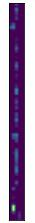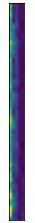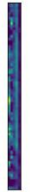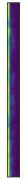
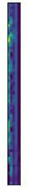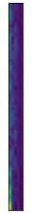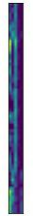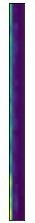
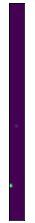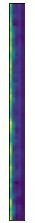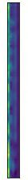

39 coeff:
Layer 1
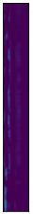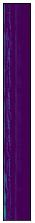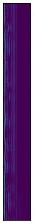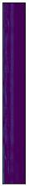
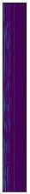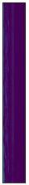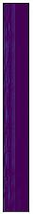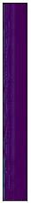
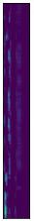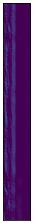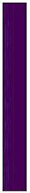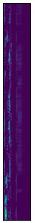
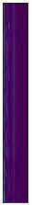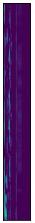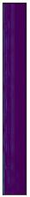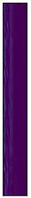

Maxpool of layer 1
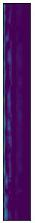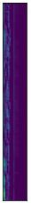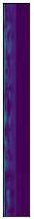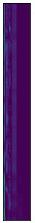
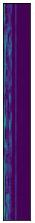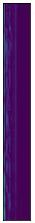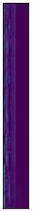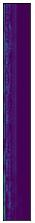
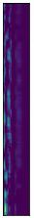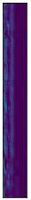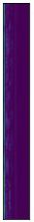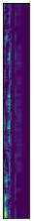
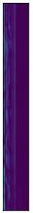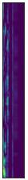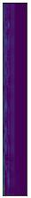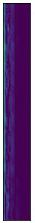

Layer 2
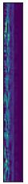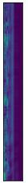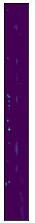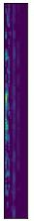
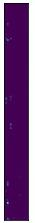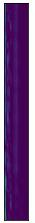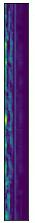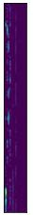
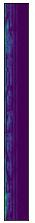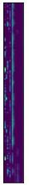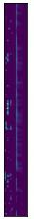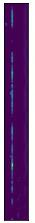
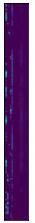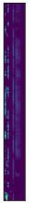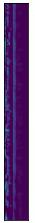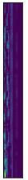
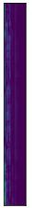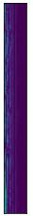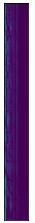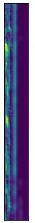
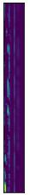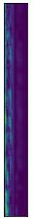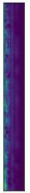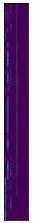
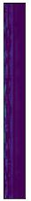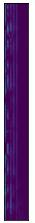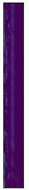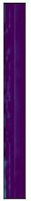
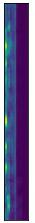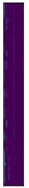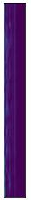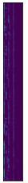

Maxpool of layer 2
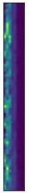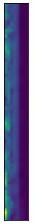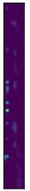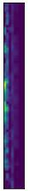
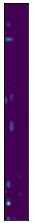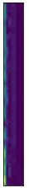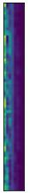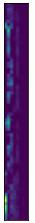
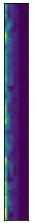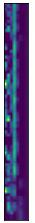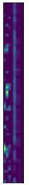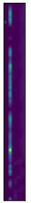
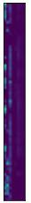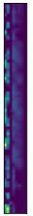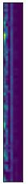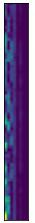
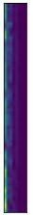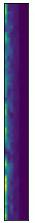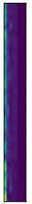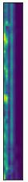
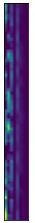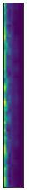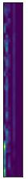
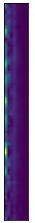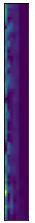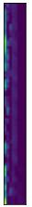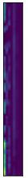
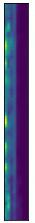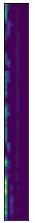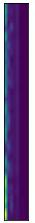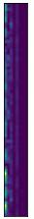

27 coeff
Layer 1
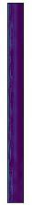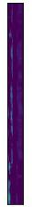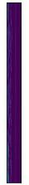
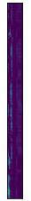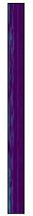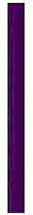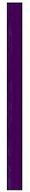
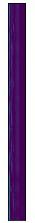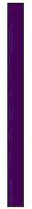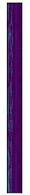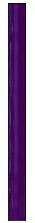
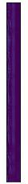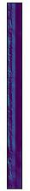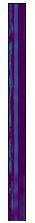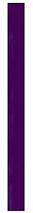

Maxpool of layer 1
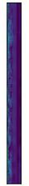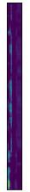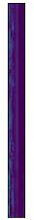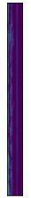
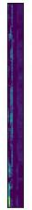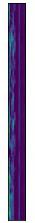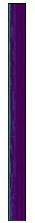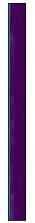
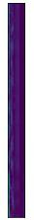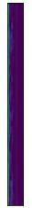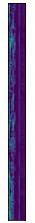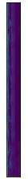
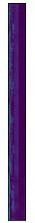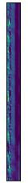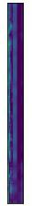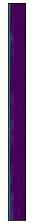

Layer 2
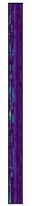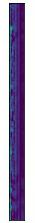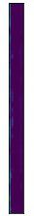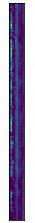
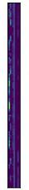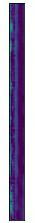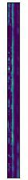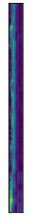
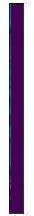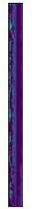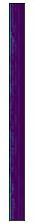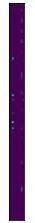
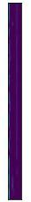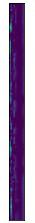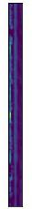
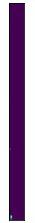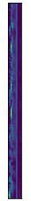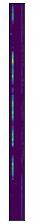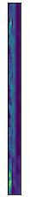
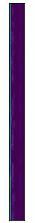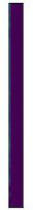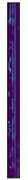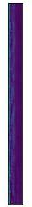
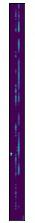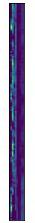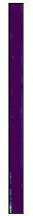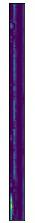
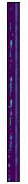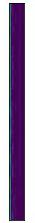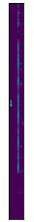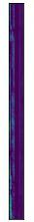

Maxpool of layer 2
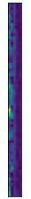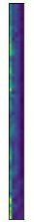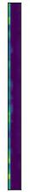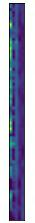
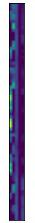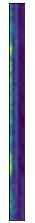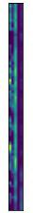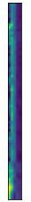
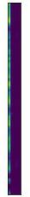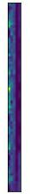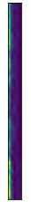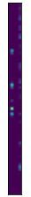
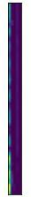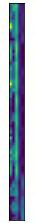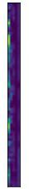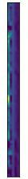
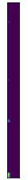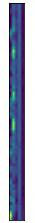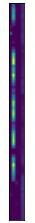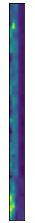
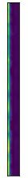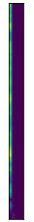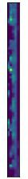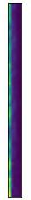
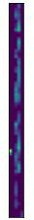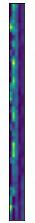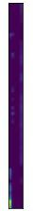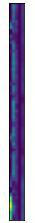
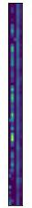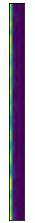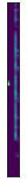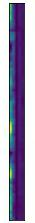

GFCC
13 coeff:
Layer 1:
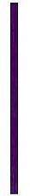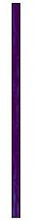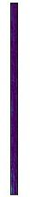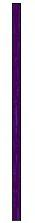
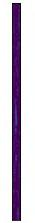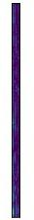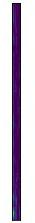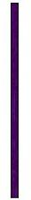
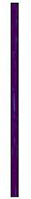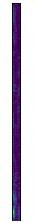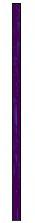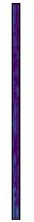
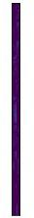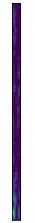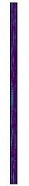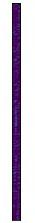

Maxpool of layer 1
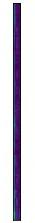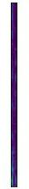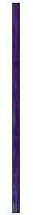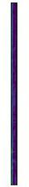
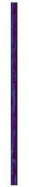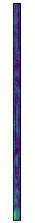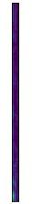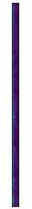
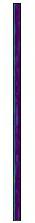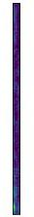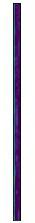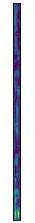
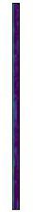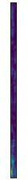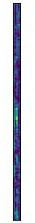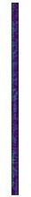

Layer 2
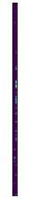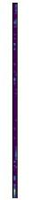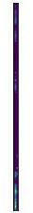
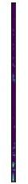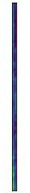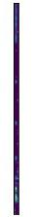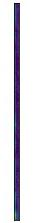
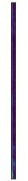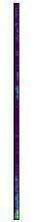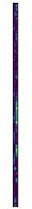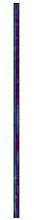
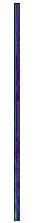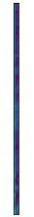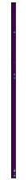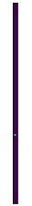
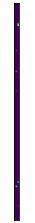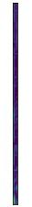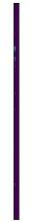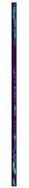
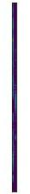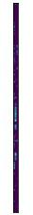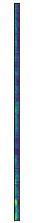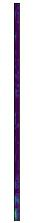
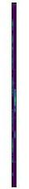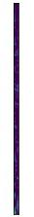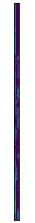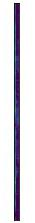
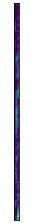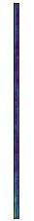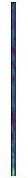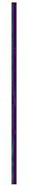

Maxpool of layer 2
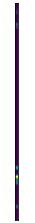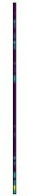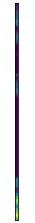
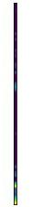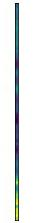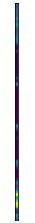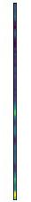
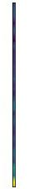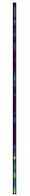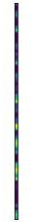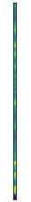
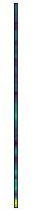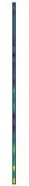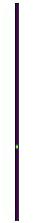
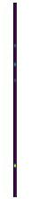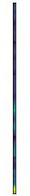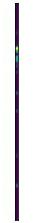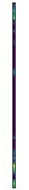
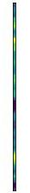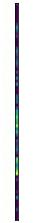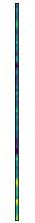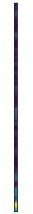
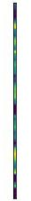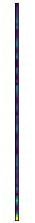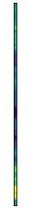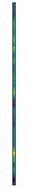
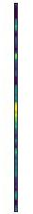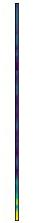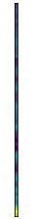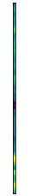

26 coeff:
Layer 1:
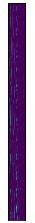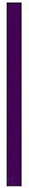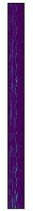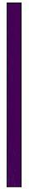
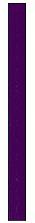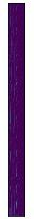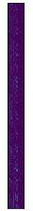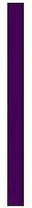
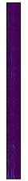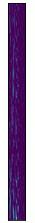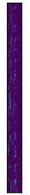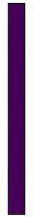
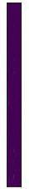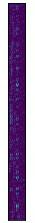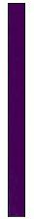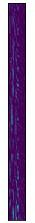

Maxpool of layer 1
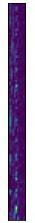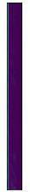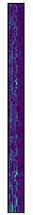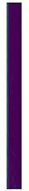
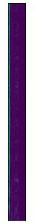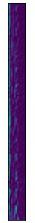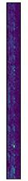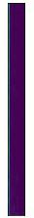
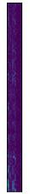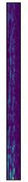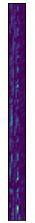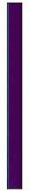
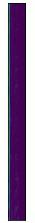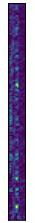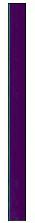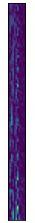

Layer 2
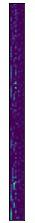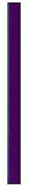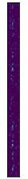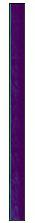
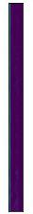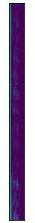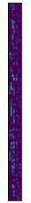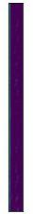
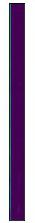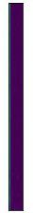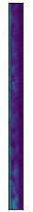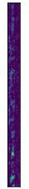
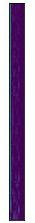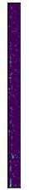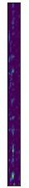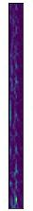
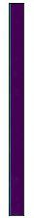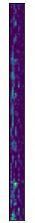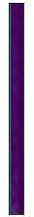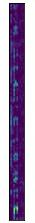
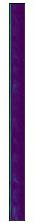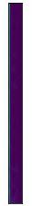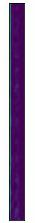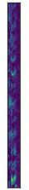
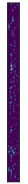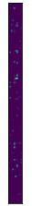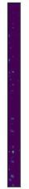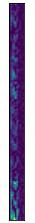
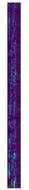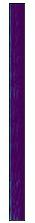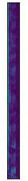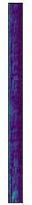

Maxpool of layer 2
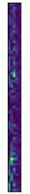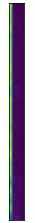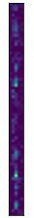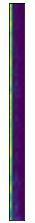
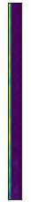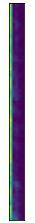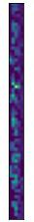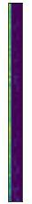
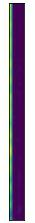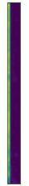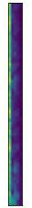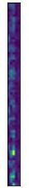
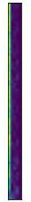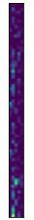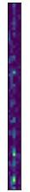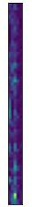
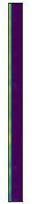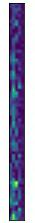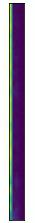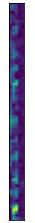
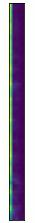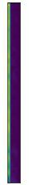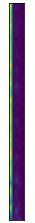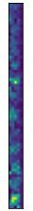
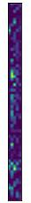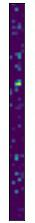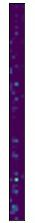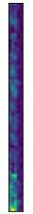
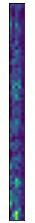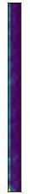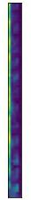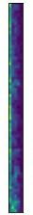

39 coeff:
Layer 1:
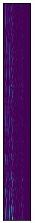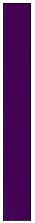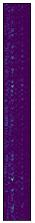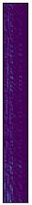
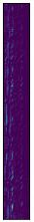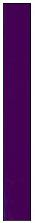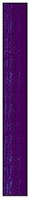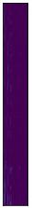
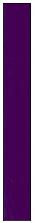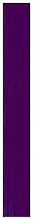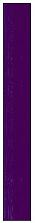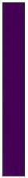
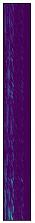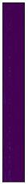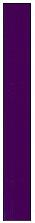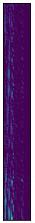

Maxpool of layer 1
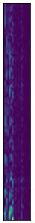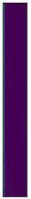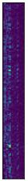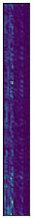
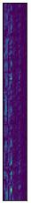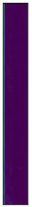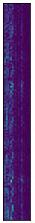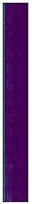
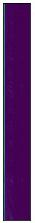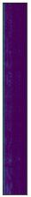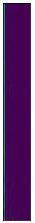
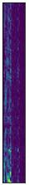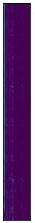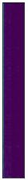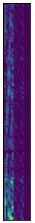

Layer 2
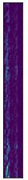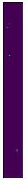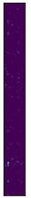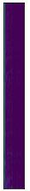
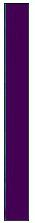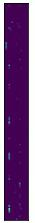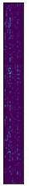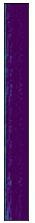
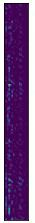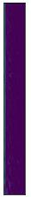
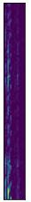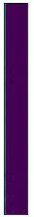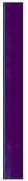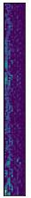
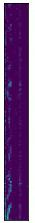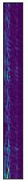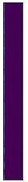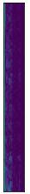
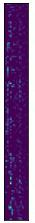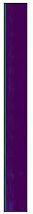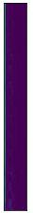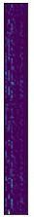
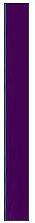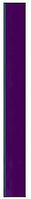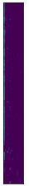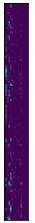
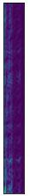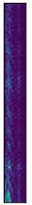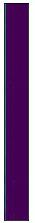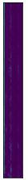

Maxpool of layer 2
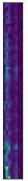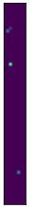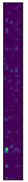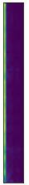
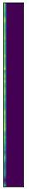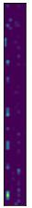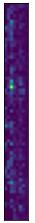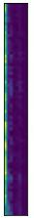
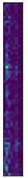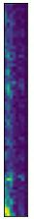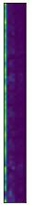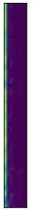
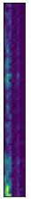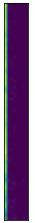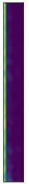
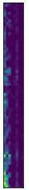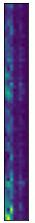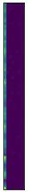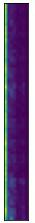
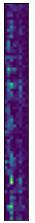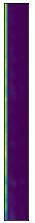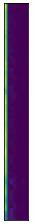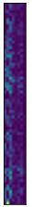
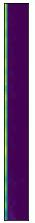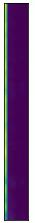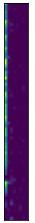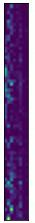
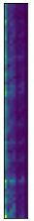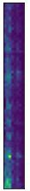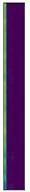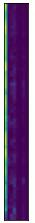

27 coeff:
Layer 1:
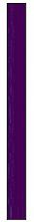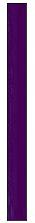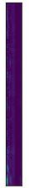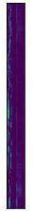
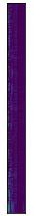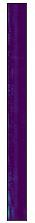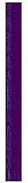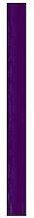
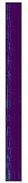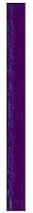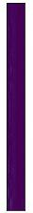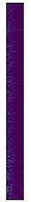
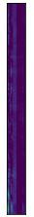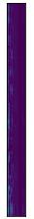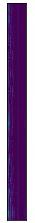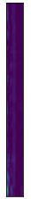

Maxpool of layer 1
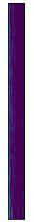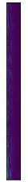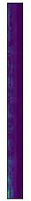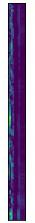
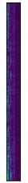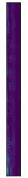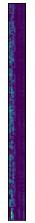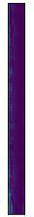
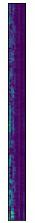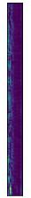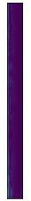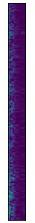
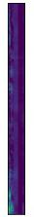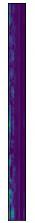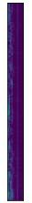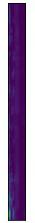

Layer 2
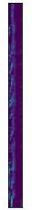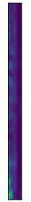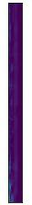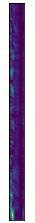
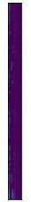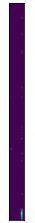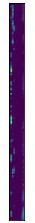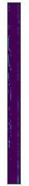
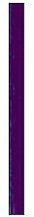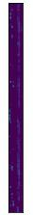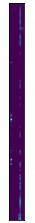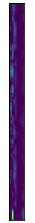
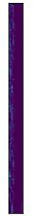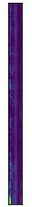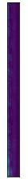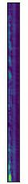
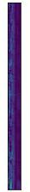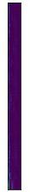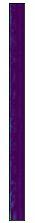
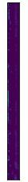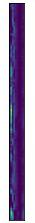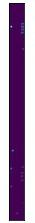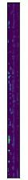
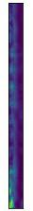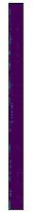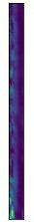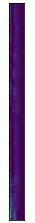
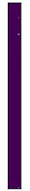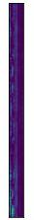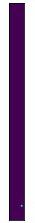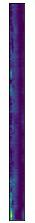

Maxpool of layer 2
